COMPANYS’ PROVILE
COMPANY: MIDIAN PROPERTIES LIMITED.
HEAD OFFICE: NEW WAUMINI HOUSE 6th FLOOR, Room 602
ADDRESS: P.O. BOX 20153 – 00100 – GPO
NAIROBI.
TELEPHONE: 0736166099, 0722 883481.
E-MAIL: midianpropertiesltd@gmail.com
Web site: www.midianproperties.com

Midian Properties Ltd
Po Box 20153 - 00100 Nbi. New Waumini House - 6th Fl.
Tel: 020 2089433. Chiromo Road
0722-883481. Westlands-Nairobi
midianpropertiesltd@gmail.com______________________________________

OUR REF ………………………… YOUR …………………….. Date: ____________

ATT: TO WHOM IT MAY CONCERN

Dear Sir / Madam
Ref: COMPANYS’ INTRODUCTION
It is with pleasure that we take this opportunity to submit our Firms CV to you for your perusal, and consideration.
Midian Properties Limited is a company incorporated on 26th August Two Thousand and Eight with the intent of Managing; Renting and Selling of the Properties in the country and more so in the up market areas of Nairobi.
Here under kindly attached is our company’s CV for your perusal
Thanking you in advance.
Yours faithfully,



Macharia J. K.
For: Midian Properties limited.
(Managing Director)

MIDIAN PROPERTIES LIMITED: Midian Properties Limited situated at New Waumini House; 6TH Floor; was registered on 26th August 2008, and established at the same time.

AGE OF THE FIRM: Eight (15) Years: 2008 - To date
DIRECTORS: 1) Mr. Jesse Kariuki Macharia
B. A. Economics and Mathematics (Hons): 1995. Practicing Estate Agent (for 26 Years. Number of years with the firm: 17 Years.
Registered with Estate Agent Registration Board, EARB No 1483
2) Mrs. Jane Wamaitha Ngugi.
KCSE (1994)

OTHER PERSONNEL:
1) ESTHER KIRIGO WAITHAKA
Secretary / Computer Assistant.
- SIMON MUHU KARONGO
Property Manager cum marketer
- STEPHEN NDICHU. MARKETING Manager.
- ALBERTA APOKO
Marketer

ESTABLISHED CLIENTS:
1) Executive Home Builders.
These are Property developers. Over the years, we have been involved in selling their developed projects in the up market areas of Nairobi.
- AMS Builders. These are some of the seasoned developers in Nairobi. We have been selling their projects in areas such as; South C; Mombasa Road, Westlands, and currently Five Star on Kiambu Rd.
- Kale Maina and company Advocates; These are listed lawyers for TelPosta Pension Scheme. In selling the Funds Properties, they had enlisted us as one of the selling agents.
- Serena Homes. This is one of the old developers of various Town houses and apartment projects in this town. Over the years, we have been moving from one project to another, in the up market areas of Kileleshwa, Kilimani and westlands.
- Marisa Limited. These are developers who develop to rent, and also for selling. We have been involved in selling and also renting out their houses.

- Leomar Court. Westlands Road. Here we are managing a court of 11 Maisonettes, and 13 Flats. RENTS:MAISONETTES: Btn Kshs.80,000/= to Kshs.138,000/= per month. APARTMENTS: Kshs.36,000 to Kshs.48,000 per unit per month.
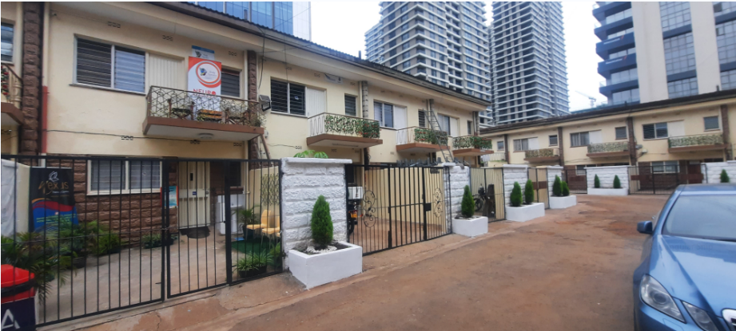
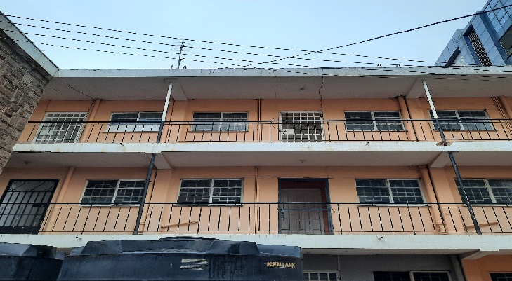

- FINCHLEY COURT; WESTLANDS; GENERAL MATHENGE LANE; Management Services. A court of 12 Flats. Rents @ Kshs.100,000/= per month per unit.


- KASARANI: CLAYWORKS; 1 & 2 Bedroom Apartments. Rent Collection: Kshs.192,000/= per month.
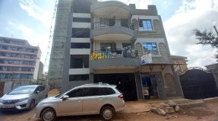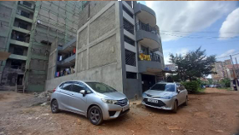
- RUNDA: GRACELINE VILLAS: A Private Residence: RENT: Kshs.250,000/=
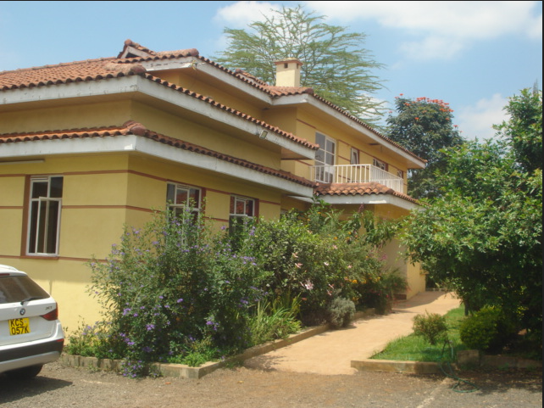

WORKS THAT WE UNDERTAKE:
- Property management
- Selling and Letting
- Maintenance and Repair.
- Consultancies in Properties.
SELLING AND RENTING OF APARTMENTS AND TOWN HOUSES.
We have been involved in selling of new development, apartments commercial blocks, and Town houses.
New developments (some off plan), and Old developments


REFEREES
- Mr. David Mbogori
Protech International Architects.
Po Box 14417 – 00800,
Nairobi.
- Mr. Kale
Kale Maina & Bundotich Co. Advocates.
13th Floor – TelPosta Towers.
Nairobi - Kenya
- M/s PATRICIA N. WARUHIU.
MANAGING PARTNER;
WARUHIU & CO. ADVOCATES.
- JAMES KIRUBI GICHURU.
60860-200 Nairobi.
MISSION
To provide an honest, credible and diligent service and information to our clients.

VISION
To be a well equipped and a dependable Estate Agency meeting aspirations and desires of Developers and Home investors within the region.

